https://nickjanetakis.com/blog/setting-up-docker-for-windows-and-wsl-to-work-flawlessly
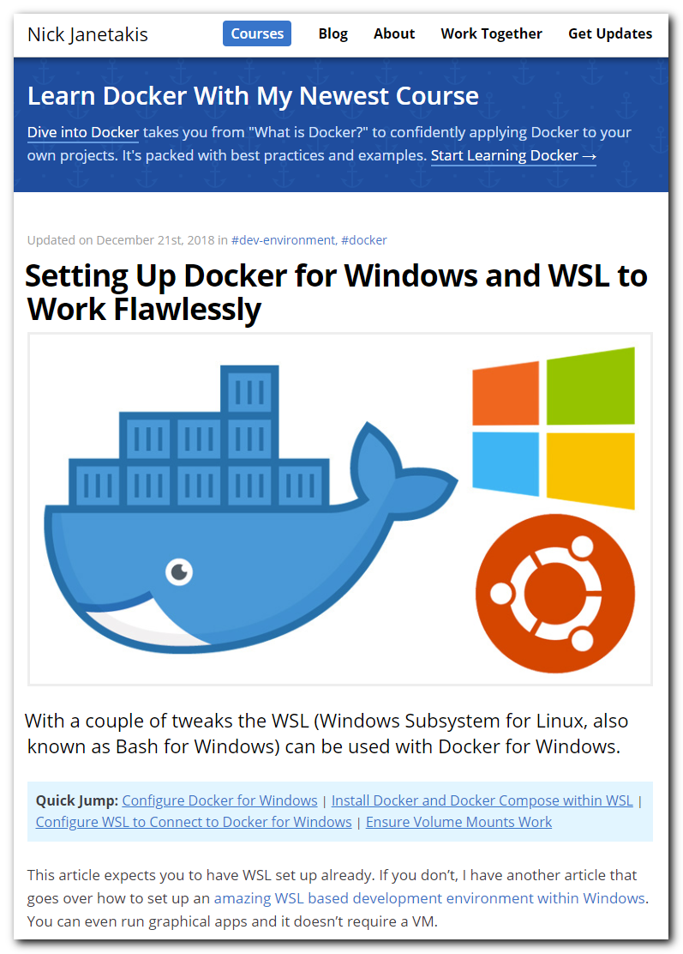

https://davidburela.wordpress.com/2018/06/27/running-docker-on-wsl-windows-subsystem-for-linux/
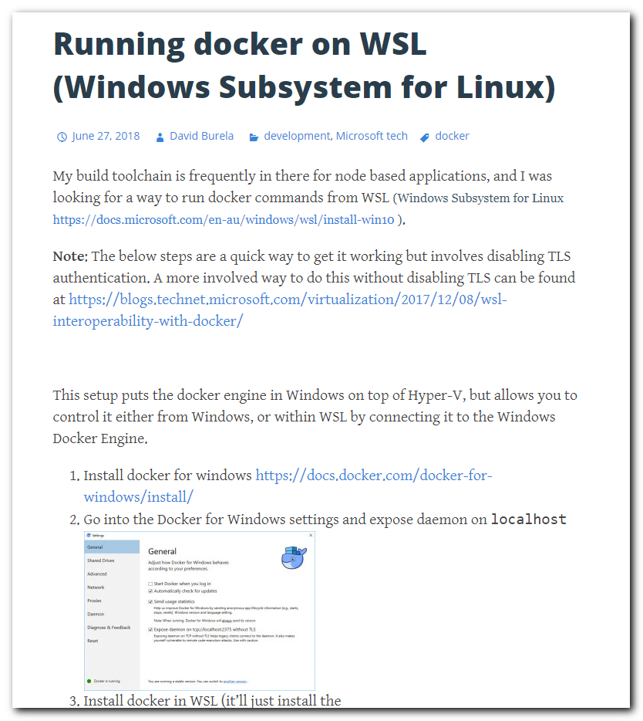
https://docs.docker.com/docker-for-windows/install/
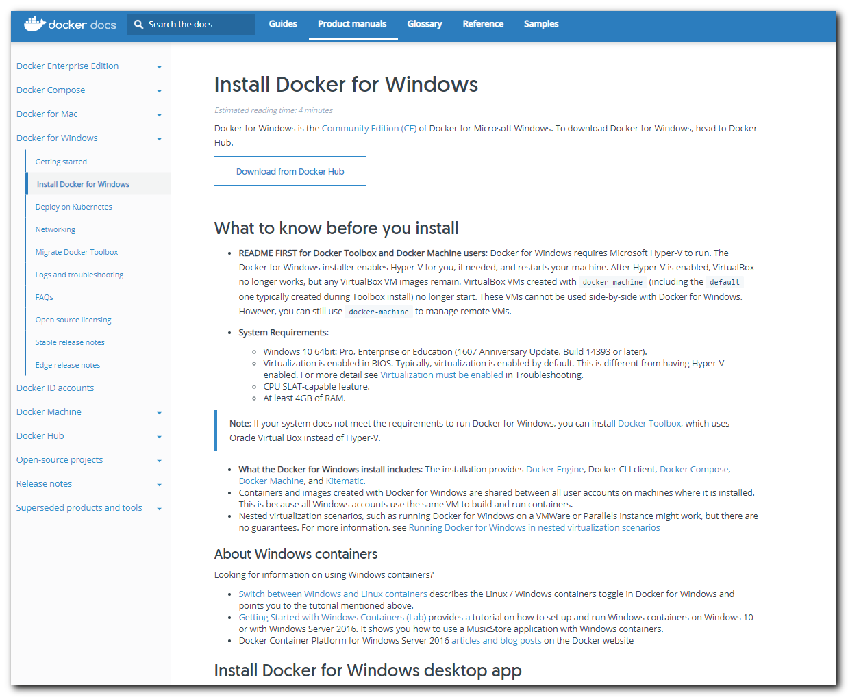

support@TCS4357:~$ sudo -i
[sudo] password for support:
root@TCS4357:~#
root@TCS4357:~#
root@TCS4357:~# apt-get update
Hit:1 http://archive.ubuntu.com/ubuntu xenial InRelease
Get:2 http://archive.ubuntu.com/ubuntu xenial-updates InRelease [109 kB]
Hit:3 http://ppa.launchpad.net/ansible/ansible/ubuntu xenial InRelease
Get:4 http://security.ubuntu.com/ubuntu xenial-security InRelease [107 kB]
Get:5 http://archive.ubuntu.com/ubuntu xenial-backports InRelease [107 kB]
Get:6 http://archive.ubuntu.com/ubuntu xenial-updates/main amd64 Packages [900 kB]
Get:7 http://archive.ubuntu.com/ubuntu xenial-updates/main Translation-en [363 kB]
Get:8 http://security.ubuntu.com/ubuntu xenial-security/main amd64 Packages [596 kB]
Get:9 http://archive.ubuntu.com/ubuntu xenial-updates/universe amd64 Packages [717 kB]
Get:10 http://archive.ubuntu.com/ubuntu xenial-updates/universe Translation-en [294 kB]
Get:11 http://security.ubuntu.com/ubuntu xenial-security/main Translation-en [248 kB]
Get:12 http://security.ubuntu.com/ubuntu xenial-security/universe amd64 Packages [411 kB]
Get:13 http://security.ubuntu.com/ubuntu xenial-security/universe Translation-en [161 kB]
Fetched 4,012 kB in 7s (513 kB/s)
Reading package lists... Done
root@TCS4357:~# apt-get install -y \
> apt-transport-https \
> ca-certificates \
> curl \
> software-properties-common
Reading package lists... Done
Building dependency tree
Reading state information... Done
software-properties-common is already the newest version (0.96.20.7).
The following packages were automatically installed and are no longer required:
ieee-data python-netaddr python-selinux
Use 'sudo apt autoremove' to remove them.
The following packages will be upgraded:
apt-transport-https ca-certificates curl libcurl3-gnutls
4 upgraded, 0 newly installed, 0 to remove and 184 not upgraded.
Need to get 517 kB of archives.
After this operation, 56.3 kB disk space will be freed.
Get:1 http://archive.ubuntu.com/ubuntu xenial-updates/main amd64 curl amd64 7.47.0-1ubuntu2.11 [139 kB]
Get:2 http://archive.ubuntu.com/ubuntu xenial-updates/main amd64 libcurl3-gnutls amd64 7.47.0-1ubuntu2.11 [185 kB]
Get:3 http://archive.ubuntu.com/ubuntu xenial-updates/main amd64 apt-transport-https amd64 1.2.29 [26.2 kB]
Get:4 http://archive.ubuntu.com/ubuntu xenial-updates/main amd64 ca-certificates all 20170717~16.04.1 [168 kB]
Fetched 517 kB in 0s (646 kB/s)
Preconfiguring packages ...
(Reading database ... 36945 files and directories currently installed.)
Preparing to unpack .../curl_7.47.0-1ubuntu2.11_amd64.deb ...
Unpacking curl (7.47.0-1ubuntu2.11) over (7.47.0-1ubuntu2.2) ...
Preparing to unpack .../libcurl3-gnutls_7.47.0-1ubuntu2.11_amd64.deb ...
Unpacking libcurl3-gnutls:amd64 (7.47.0-1ubuntu2.11) over (7.47.0-1ubuntu2.2) ...
Preparing to unpack .../apt-transport-https_1.2.29_amd64.deb ...
Unpacking apt-transport-https (1.2.29) over (1.2.20) ...
Preparing to unpack .../ca-certificates_20170717~16.04.1_all.deb ...
Unpacking ca-certificates (20170717~16.04.1) over (20160104ubuntu1) ...
Processing triggers for man-db (2.7.5-1) ...
Processing triggers for libc-bin (2.23-0ubuntu9) ...
Setting up libcurl3-gnutls:amd64 (7.47.0-1ubuntu2.11) ...
Setting up curl (7.47.0-1ubuntu2.11) ...
Setting up apt-transport-https (1.2.29) ...
Setting up ca-certificates (20170717~16.04.1) ...
Processing triggers for libc-bin (2.23-0ubuntu9) ...
Processing triggers for ca-certificates (20170717~16.04.1) ...
Updating certificates in /etc/ssl/certs...
17 added, 42 removed; done.
Running hooks in /etc/ca-certificates/update.d...
done.
root@TCS4357:~# curl -fsSL https://download.docker.com/linux/ubuntu/gpg | sudo apt-key add -
OK
root@TCS4357:~# apt-key fingerprint 0EBFCD88
pub 4096R/0EBFCD88 2017-02-22
Key fingerprint = 9DC8 5822 9FC7 DD38 854A E2D8 8D81 803C 0EBF CD88
uid Docker Release (CE deb) <docker@docker.com>
sub 4096R/F273FCD8 2017-02-22

root@TCS4357:~# add-apt-repository \
> "deb [arch=amd64] https://download.docker.com/linux/ubuntu \
> $(lsb_release -cs) \
> stable"
root@TCS4357:~# apt-get update
Hit:1 http://archive.ubuntu.com/ubuntu xenial InRelease
Hit:2 http://archive.ubuntu.com/ubuntu xenial-updates InRelease
Hit:3 http://ppa.launchpad.net/ansible/ansible/ubuntu xenial InRelease
Hit:4 http://archive.ubuntu.com/ubuntu xenial-backports InRelease
Hit:5 http://security.ubuntu.com/ubuntu xenial-security InRelease
Get:6 https://download.docker.com/linux/ubuntu xenial InRelease [66.2 kB]
Get:7 https://download.docker.com/linux/ubuntu xenial/stable amd64 Packages [5,491 B]
Fetched 71.7 kB in 4s (14.8 kB/s)
Reading package lists... Done
root@TCS4357:~#

root@TCS4357:~# apt-get install -y docker-ce
Reading package lists... Done
Building dependency tree
Reading state information... Done
The following packages were automatically installed and are no longer required:
ieee-data python-netaddr python-selinux
Use 'sudo apt autoremove' to remove them.
The following additional packages will be installed:
aufs-tools cgroupfs-mount containerd.io docker-ce-cli libltdl7 libseccomp2 pigz
Suggested packages:
mountall
The following NEW packages will be installed:
aufs-tools cgroupfs-mount containerd.io docker-ce docker-ce-cli libltdl7 pigz
The following packages will be upgraded:
libseccomp2
1 upgraded, 7 newly installed, 0 to remove and 183 not upgraded.
Need to get 50.5 MB of archives.
After this operation, 243 MB of additional disk space will be used.
Get:1 http://archive.ubuntu.com/ubuntu xenial/universe amd64 pigz amd64 2.3.1-2 [61.1 kB]
Get:2 http://archive.ubuntu.com/ubuntu xenial-updates/main amd64 libseccomp2 amd64 2.3.1-2.1ubuntu2~16.04.1 [38.7 kB]
Get:3 http://archive.ubuntu.com/ubuntu xenial/universe amd64 aufs-tools amd64 1:3.2+20130722-1.1ubuntu1 [92.9 kB]
Get:4 http://archive.ubuntu.com/ubuntu xenial/universe amd64 cgroupfs-mount all 1.2 [4,970 B]
Get:5 http://archive.ubuntu.com/ubuntu xenial/main amd64 libltdl7 amd64 2.4.6-0.1 [38.3 kB]
Get:6 https://download.docker.com/linux/ubuntu xenial/stable amd64 containerd.io amd64 1.2.0-1 [19.9 MB]
Get:7 https://download.docker.com/linux/ubuntu xenial/stable amd64 docker-ce-cli amd64 5:18.09.0~3-0~ubuntu-xenial [13.0 MB]
Get:8 https://download.docker.com/linux/ubuntu xenial/stable amd64 docker-ce amd64 5:18.09.0~3-0~ubuntu-xenial [17.4 MB]
Fetched 50.5 MB in 4s (11.9 MB/s)
Selecting previously unselected package pigz.
(Reading database ... 36919 files and directories currently installed.)
Preparing to unpack .../pigz_2.3.1-2_amd64.deb ...
Unpacking pigz (2.3.1-2) ...
Preparing to unpack .../libseccomp2_2.3.1-2.1ubuntu2~16.04.1_amd64.deb ...
Unpacking libseccomp2:amd64 (2.3.1-2.1ubuntu2~16.04.1) over (2.2.3-3ubuntu3) ...
Processing triggers for man-db (2.7.5-1) ...
Processing triggers for libc-bin (2.23-0ubuntu9) ...
Setting up libseccomp2:amd64 (2.3.1-2.1ubuntu2~16.04.1) ...
Processing triggers for libc-bin (2.23-0ubuntu9) ...
Selecting previously unselected package aufs-tools.
(Reading database ... 36927 files and directories currently installed.)
Preparing to unpack .../aufs-tools_1%3a3.2+20130722-1.1ubuntu1_amd64.deb ...
Unpacking aufs-tools (1:3.2+20130722-1.1ubuntu1) ...
Selecting previously unselected package cgroupfs-mount.
Preparing to unpack .../cgroupfs-mount_1.2_all.deb ...
Unpacking cgroupfs-mount (1.2) ...
Selecting previously unselected package containerd.io.
Preparing to unpack .../containerd.io_1.2.0-1_amd64.deb ...
Unpacking containerd.io (1.2.0-1) ...
Selecting previously unselected package libltdl7:amd64.
Preparing to unpack .../libltdl7_2.4.6-0.1_amd64.deb ...
Unpacking libltdl7:amd64 (2.4.6-0.1) ...
Selecting previously unselected package docker-ce-cli.
…
Setting up cgroupfs-mount (1.2) ...
invoke-rc.d: could not determine current runlevel
Setting up containerd.io (1.2.0-1) ...
Setting up libltdl7:amd64 (2.4.6-0.1) ...
Setting up docker-ce-cli (5:18.09.0~3-0~ubuntu-xenial) ...
Setting up docker-ce (5:18.09.0~3-0~ubuntu-xenial) ...
update-alternatives: using /usr/bin/dockerd-ce to provide /usr/bin/dockerd (dockerd) in auto mode
Processing triggers for libc-bin (2.23-0ubuntu9) ...
Processing triggers for systemd (229-4ubuntu17) ...
Processing triggers for ureadahead (0.100.0-19) ...
root@TCS4357:~#

root@TCS4357:~# usermod -aG docker support
root@TCS4357:~#

root@TCS4357:~# docker run hello-world
docker: Cannot connect to the Docker daemon at unix:///var/run/docker.sock. Is the docker daemon running?.
See 'docker run --help'.
root@TCS4357:~# systemctl status docker
Failed to connect to bus: No such file or directory
root@TCS4357:~#

root@TCS4357:~# exit
logout
support@TCS4357:~$ exit

support@TCS4357:~$ docker run hello-world
docker: Cannot connect to the Docker daemon at unix:///var/run/docker.sock. Is the docker daemon running?.
See 'docker run --help'.
support@TCS4357:~$ sudo -i
[sudo] password for support:
root@TCS4357:~# systemctl status docker
Failed to connect to bus: No such file or directory
root@TCS4357:~# systemctl start docker
Failed to connect to bus: No such file or directory
root@TCS4357:~# cat /etc/os-release
NAME="Ubuntu"
VERSION="16.04.2 LTS (Xenial Xerus)"
ID=ubuntu
ID_LIKE=debian
PRETTY_NAME="Ubuntu 16.04.2 LTS"
VERSION_ID="16.04"
HOME_URL="http://www.ubuntu.com/"
SUPPORT_URL="http://help.ubuntu.com/"
BUG_REPORT_URL="http://bugs.launchpad.net/ubuntu/"
VERSION_CODENAME=xenial
UBUNTU_CODENAME=xenial
root@TCS4357:~#

https://docs.docker.com/docker-for-windows/install/
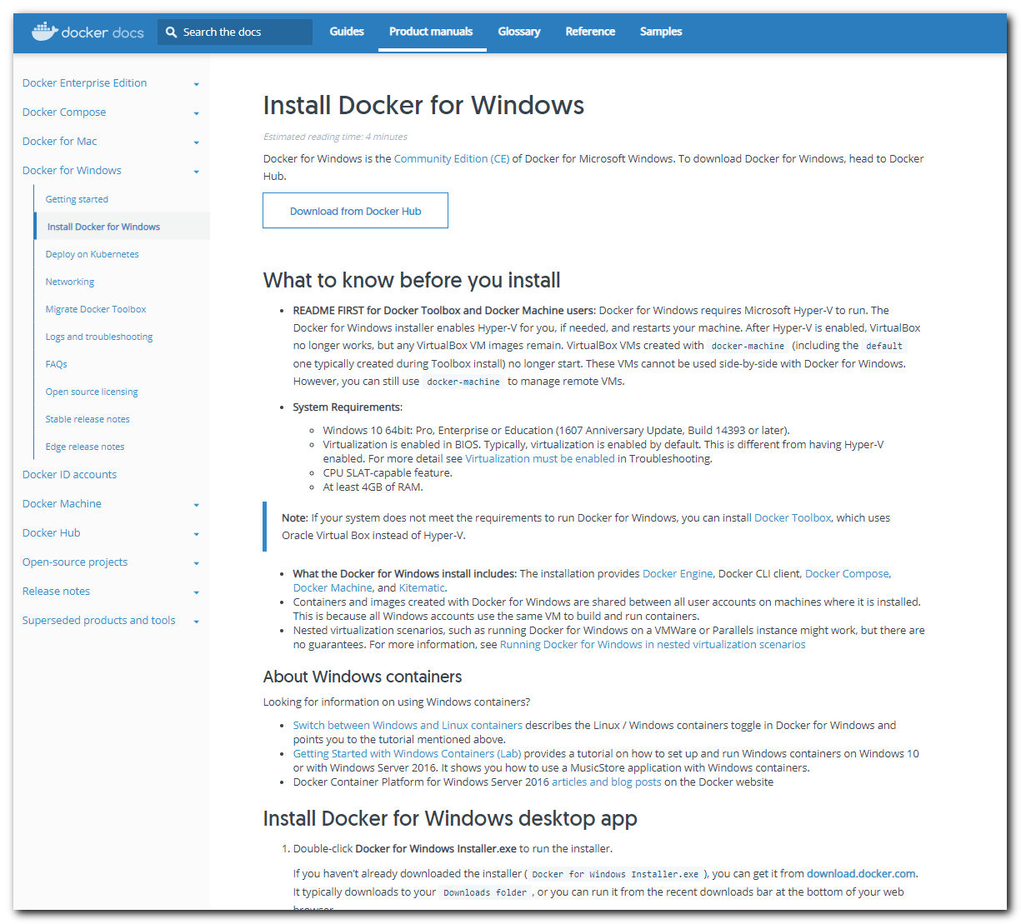

https://hub.docker.com/editions/community/docker-ce-desktop-windows
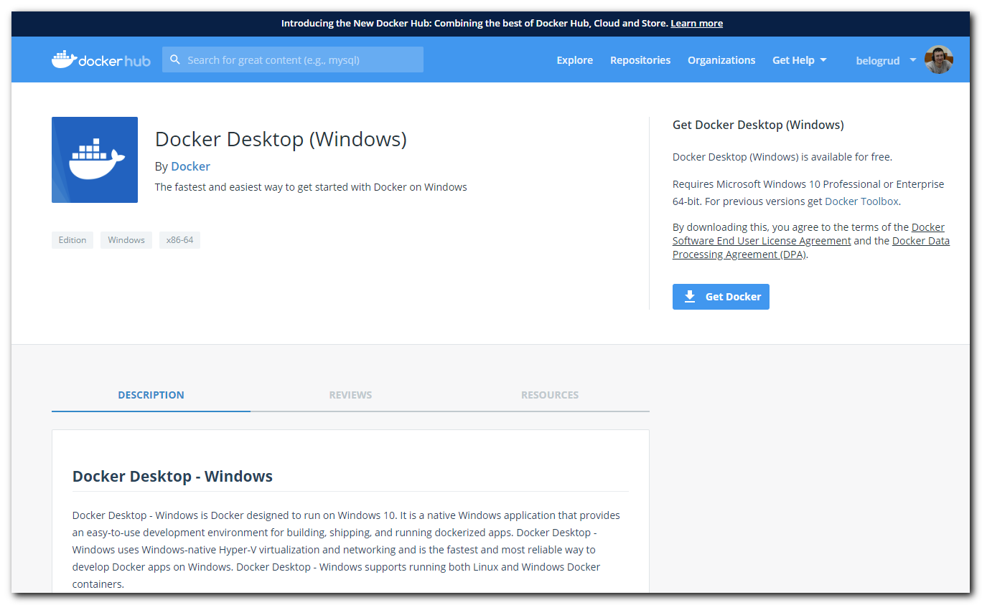

#
# After installation required logout and login again to windows.
# All opened applications will be destroyed….
# It’s ms windows….

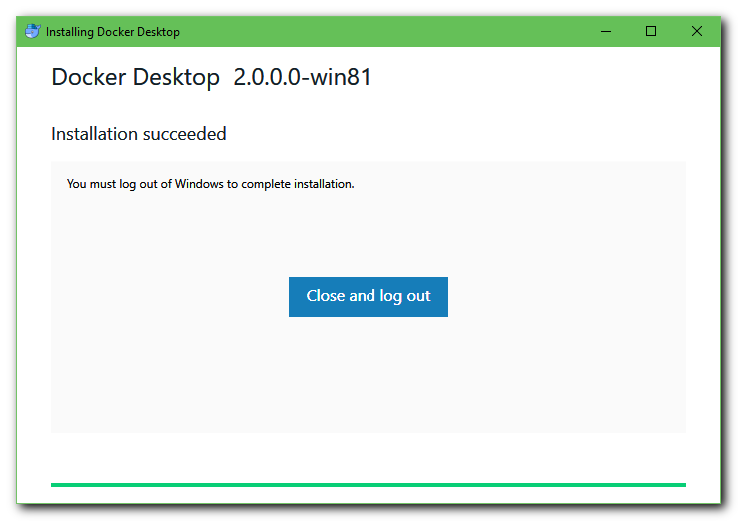

#
# I need to use VirtualBox, so I’ve cancelled configuration at this screen.
